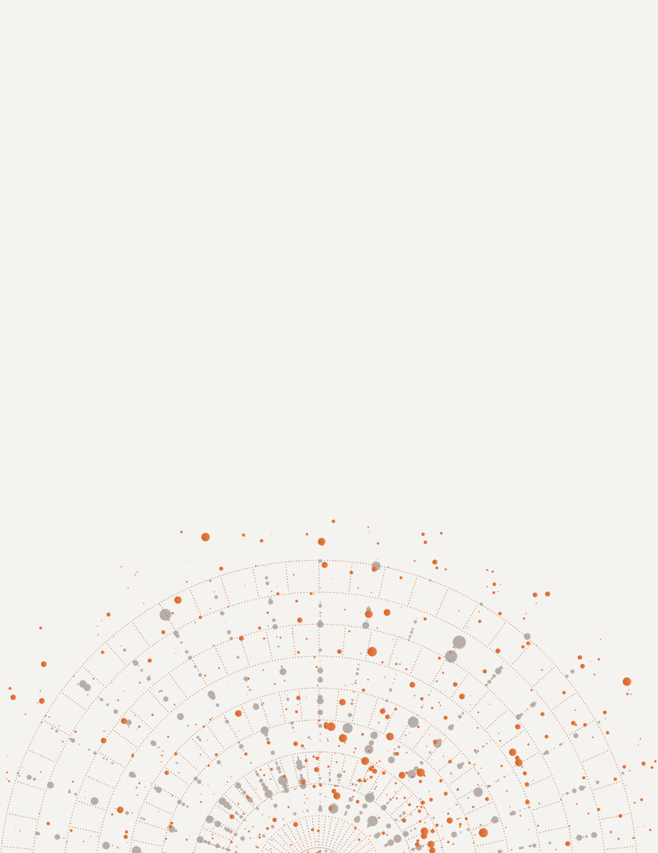

Final Report
Fall 2025

From the Ground Up
A National Portrait of Latinx/é Arts and Culture Organizations
Presented by:  NORC at the University of Chicago |  | Presented to:  National Association of Latino Arts and Culture

Table of Contents
Executive Summary 1
Introduction 1
Partners & Sponsors 1
Survey Methodology Overview 1
How to Use this Report 2
Organization Profile 3
Geography 3
Primary Mission 3
Legal Incorporation Status 5
Programs and Disciplines 6
Primary Artistic Disciplines 7
Changes in Demand & Unmet Needs 7
Cross-Sector Program Partnerships 8
Communities Served 9
Diasporic Regions & Cultural Heritage 10
Indigenous Community Engagement 10
Service Footprint 11
Staffing, Leadership, and Organizational Capacity 11
Staffing 12
Leadership 13
Benefits 13
Staffing Challenges 14
Organizational Challenges and Resilience Since 2020 15
Capacity Changes Since 2020 15
New Directions Since 2020 18
Facilities and Infrastructure 19
Ownership of Facilities 19
Location of Facilities 20
Community Access to Facilities 21
Financial State and Revenue Sources 21
Annual Budget Size 21
Revenue Sources 22
Financial Health 23
Financial Challenges 24
Appendix A: Data Collection 26
Appendix B: Survey Instrument (English) 28
Appendix C: Survey Instrument (Español) 29
Appendix D: Construct Matrix & Item Map 30
Appendix E: Survey Results 31
Apply Text Styles 58
Introduction (Heading 2) 58
Heading 3 58
Heading 4 58
Apply Color 58
Insert Built-in NOR Experience, Call Out, and Quote Block 59
Insert Exhibits 59
Insert Tables 60

List of Figures
Figure 1. Organization's mission or purpose 4
Figure 2. Organization's legal incorporation status 6
Figure 3. Change in demand for programs since 2020 7
Figure 4. Change in demand for programs since 2020 8
Figure 5. Actions taken or planned since 2020 (select all that apply) 9
Figure 6. Program service footprint 11
Figure 7. Total number of staff members by role 12
Figure 8. Median number of staff members and latinx/e staff members 13
Figure 9. Benefits offered to full-time and part-time employees 14
Figure 10. Greatest staffing challenges 15
Figure 11. Organizational changes since 2020 16
Figure 12. Details of organizational changes since 2020 16
Figure 13. Change in demand for programs since 2020 17
Figure 14. Ability to meet demand for programs in last fiscal year 17
Figure 15. Actions taken or planned since 2020 (select all that apply) 18
Figure 16. Partnerships with other organizations to offer programs in... 19
Figure 17. Organizations that own, rent, or lease office and/or facilities 20
Figure 18. Organization's with offices or facilities within at least one of the communities served 20
Figure 19. Organization's annual budget 21
Figure 20. Organization's revenue sources 22
Figure 21. Changes in revenue by source since 2020 23
Figure 22. Financial status of organization in last fiscal year 24
Figure 23. Organization’s greatest financial challenges 25
Figure 24. Percentage of total funding that was unrestricted in last fiscal year 25

List of Tables
Table 1. NORC Table Caption 4
Table 2. NORC Table Caption 4
Table 3. NORC Table Caption 4
Table 4. NORC Table Caption 4

Executive Summary
- Brief overview of the purpose, methodology, and key findings
- Snapshot infographics (e.g., % Latinx-led, top program types, budget ranges)
- High-level takeaways for funders, advocates, and policymakers

Introduction
The 2024 National Latinx/é Arts & Culture Survey was designed to fill a critical gap in knowledge related to Latinx/é arts and culture organizations in the continental United States and Puerto Rico. The sector has historically been underrepresented in major data collection efforts. Building on NALAC’s original 2019 effort, this updated survey aimed to provide a broader and more current overview of organizational capacities, programs, funding sources, and sustainability challenges—particularly in a post-pandemic recovery context. Key objectives included expanding NALAC’s national directory of Latinx/é arts organizations, boosting survey participation from 2019, and developing a robust evidence base to support advocacy and inform funders and policymakers. The survey assessed the overall landscape of organizations founded by, led by, and serving Latinx/é communities, with modules covering communities served, staffing and leadership, facilities, finances, and programs.

Partners & Sponsors
The survey was fielded by the National Association of Latino Arts & Cultures (NALAC) in partnership with NORC at the University of Chicago, with funding from The Wallace Foundation. NALAC led the project and field engagement, while NORC served as the independent research partner for survey design, administration, and analysis.

Survey Methodology Overview
Recruitment and sample. The survey targeted arts and culture organizations founded by, led by, and serving Latinx/é people across the United States and Puerto Rico. Invitations were distributed by NORC via email. Surveys required a unique PIN for completion by a knowledgeable organizational representative and took an average of 15 minutes to complete. The questionnaire was available in both English and Spanish.
The study team conducted data collection in two waves. Wave 1 targeted NALAC’s existing list of organizations. Wave 2 expanded the sample frame with an experimental approach combining purchased Latinx-owned business records, a peer referral process completed by Wave 1 survey respondents, and a self-referral process.
Administration timeline and incentives. The survey opened in October of 2024 and closed in March 2025. To bolster response, NORC’s Telephone Survey & Support Operations (TSSO) conducted follow-up calls beginning mid-November 2024—placing 10,000+ calls to nearly 3,000 records. All participants were offered a $40 virtual gift card incentive.
Final sample overview. This report analyzes responses from 493 unique organizations.

How to Use this Report
This report presents descriptive statistics across nine sections that mirror the survey modules:
- Organizational Profile
- Programs and Disciplines
- Communities Served
- Staffing, Leadership, and Organizational Capacity
- Organizational Challenges and Resilience Since 2020
- Facilities and Infrastructure
- Financial Health and Revenue Sources
Because recruitment combined network-based outreach and experimental list-building (i.e., not a probability sample), these descriptive statistics describe responding organizations only and do not estimate population parameters. This means that results are not statistically generalizable to all Latinx/é arts and culture organizations in the U.S. and Puerto Rico. Readers should not make causal or impact inferences from the data. Descriptive statistics are intended to highlight patterns and areas for further exploration, not test hypotheses. Where comparisons are made to external benchmarks (e.g., U.S. Hispanic/Latino population shares), readers should treat them as contextual rather than inferential.

Organizational Profile
This section establishes a foundational understanding of the Latinx/é arts and culture organizations that participated in the survey. It includes basic descriptors such as geography, mission, and tax status. These data points help capture the breadth and diversity of the field—from informal collectives to long-standing nonprofits, from local community hubs to national and transnational organizations.

Geography

Figure 1. Organizations' locations within the United States
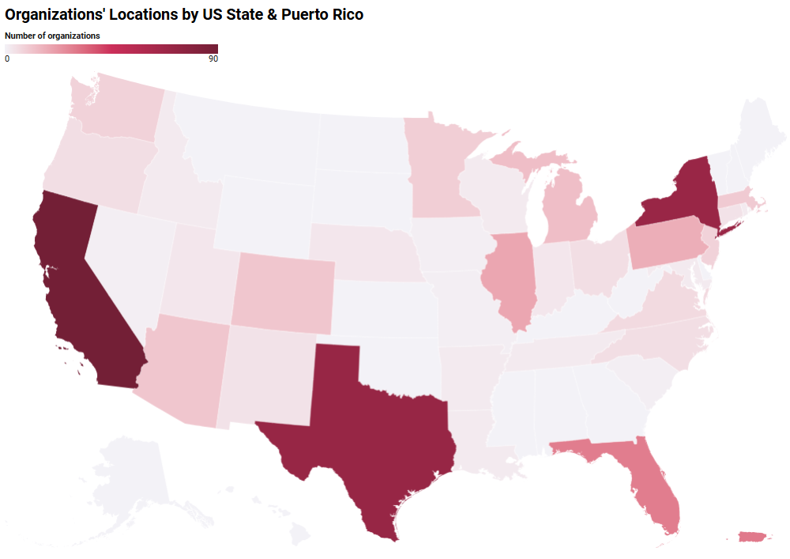

Primary Mission
Organizations most commonly identified their primary mission as Artistic Production (21%) or Performance/Presenting (21%), underscoring a strong emphasis on creating and showcasing creative work (Figure 2). A substantial share also occupied field-support roles: Arts Services Organizations (17%) and Arts Training/Education/Professional Development (13%). Smaller segments reported missions such as Museum/Gallery/Exhibition Space (4%), Advocacy/Policy (3%), Social Services (3%), Literary Press/Publisher (2%), Fair/Festival (2%), and Historical or Cultural Society/Commission (2%), with all remaining categories at <2%.
Figure 2. Organization's mission or purpose

Legal Incorporation Status
Just over two-thirds (68%) of organizations report their legal incorporation status as a 501(c)(3) charity/non-profit, indicating that formal nonprofit status is the dominant structure in the Latinx/é arts and culture field (Figure 2). Very few identified as other nonprofit tax classifications such as 501(c)(3) foundations (<1%), 501(c)(4) organizations (<1%), or 501(c)(6) entities (<1%).
Figure 3. Organization's legal incorporation status

Notably, when reporting on legal incorporation status 15% selected “Other.” Open-ended responses to this category revealed a diverse range of arrangements outside standard nonprofit classifications. Through coding of these write-in responses, two additional categories emerged that were not provided as fixed response options in the original question: for-profit Limited Liability Companies (LLCs) (8%) and fiscally sponsored organizations (6%). LLC respondents included variations such as sole-proprietor LLCs and LLC partnerships. Fiscally sponsored organizations described partnering with established nonprofits or umbrella organizations to access the administrative benefits of nonprofit status—such as receiving tax-deductible donations, accounting, and compliance—without going through the formal legal process of creating an independent 501(c)(3).
“Other” responses encompassed S corporations, C corporations, municipal or state entities, universities, research institutes, and public institutions, as well as unincorporated collectives, grassroots groups, and individual artist projects, reflecting the informal or community-based nature of much of the work in this field. A small subset noted in-process incorporation or former 501(c)(3) status that was dissolved in favor of other structures. Taken together, these varied responses underscore the flexibility and adaptive strategies Latinx/é arts and culture practitioners employ to sustain their work, often balancing administrative capacity, funding access, and community priorities.

Programs and Disciplines
The next section of the survey documented the types of programs and services offered by Latinx/é arts organizations, including artistic disciplines programmatic partnerships, and community-based services. Programming is often the most visible expression of an organization’s mission and cultural identity. By capturing the breadth of offerings—from traditional arts to contemporary and interdisciplinary practices, from arts education to health-related programming—this section describes the varied role Latinx/é arts organizations play in community well-being, cultural preservation, and social change.

Primary Artistic Disciplines
When asked to select up to three primary artistic disciplines their organization focuses on, Figure XX shows that a majority of organizations identified Performing Arts (62%), followed by Visual Arts (45%) and Traditional or Folk Arts (43%). Roughly one in four organizations reported Other Arts (26%) or Writing/Literature (25%) as a primary discipline of focus. Smaller proportions identified Craft (11%) or Design (4%). These results illustrate the field’s strong representation in live performance, visual traditions, while also reflecting significant engagement with visual and culturally rooted practices.
Figure 4. Primary art discipline(s) (select up to 3)

Changes in Demand & Unmet Needs
Since 2020, most organizations reported rising demand for their programs: as Figure XX shows, 73% experienced increases (including 51% reporting a significant increase and 23% a slight increase). About 10% saw no change in demand for their programs, while 15% reported decreases (8% slight; 7% significant). Overall, the distribution points to a strong post-2020 rebound in audience and community demand.
Figure 5. Change in demand for programs since 2020

Nearly half of organizations (47%) reported that the reach of their programs or services changed since 2020. Among those who answered the follow-up, three-quarters said reach increased (74%) while the remaining quarter reported a decrease (26%), indicating a net tilt toward expanded audience/service reach in the post-2020 period.
Despite these gains in reach, unmet need was widespread: in the last fiscal year, 48% of respondents said they could not fully meet demand for programs because they lacked funding, staff, and/or necessary resources, roughly matching the share who said they could (47%).
Operationally, organizations most often pointed to funding and cash-flow constraints (78%) as a top challenge, followed by managing or pursuing organizational growth (39%) and lack of physical space (36%). Additional capacity gaps included connecting with new audiences (22%), data management (17%), and HR management (17%). Taken together, the findings suggest that while demand and reach often grew after 2020, many organizations struggled to resource that growth—particularly around financing, space, and organizational infrastructure.

Cross-Sector Program Partnerships
In the context of this rising demand and persistent capacity constraints, nearly three-quarters (72%) of organizations reported having established collaborations or partnerships with new organizations (Figure XX). They most commonly partnered in youth development (49%) and health (32%), followed by immigration (21%) and workforce and economic development (16% and 15%). Notable shares also collaborated around agriculture & food and environment & energy (each 13%), signaling cross-sector strategies that address community needs linked to access, well-being, and stability. Smaller—but present—partnerships in housing, public safety, transportation, art, and education suggest targeted efforts where resources or local contexts allow. Taken together with other findings, these patterns indicate collaboration may have helped extend reach, share space and staff, co-produce programs, and mitigate funding and cash-flow pressures—some of which were top operational challenges identified.
Figure 6. Actions taken or planned since 2020 (select all that apply)

Many also sought input from their communities (38%) and acted on that feedback (34%), suggesting an intentional effort to align programs with evolving post-2020 needs. About a third developed succession plans (32%), a signal of attention to leadership continuity amid growth and turnover, and one-quarter engaged more formally in advocacy and policy (26%), consistent with field-level efforts to address systemic issues (e.g., funding, space). Only 10% reported taking none of these actions, and relatively few merged with another organization (3%) or undertook formal strategic planning (3%). Overall, the pattern points to practical, near-term strategies—collaboration, community feedback loops, and leadership stabilization—used to meet increased demand despite ongoing resource gaps.

Communities Served
This section examines the geographic and cultural demographics of the communities served by Latinx/é arts organizations. This portion of the survey was included to better understand the audience and community relationships that define the sector. Survey findings indicate that many organizations serve diverse and intersectional communities, including Black, Indigenous, and other communities of color. These findings affirm that Latinx/é cultural work often centers multilingual, diasporic, and cross-racial community engagement—an important distinction that has implications for funding, program design, and public policy.

Diasporic Regions & Cultural Heritage
Surveyed organizations reported serving communities connected to a wide range countries and territories that have been part of the Latin American diaspora, reflecting the geographic and cultural diversity of the Latinx/é arts and culture field.
When completing this section of the survey, organizations had the opportunity to indicate all communities they serve, meaning that answers were not mutually exclusive and thus percentages reported here reflect the share of organizations naming each community. The largest proportions of organizations reported serving communities with heritage from Mexico (51%) and the United States (51%). The next highest were Puerto Rico (34%), the Dominican Republic (23%), Colombia (23%), and Cuba (23%). In national context, those of Mexican descent comprise about 60% of U.S. Latinx/é identified individuals. Puerto Ricans comprise 9% of Latinx/é identified individuals in the U.S., while Dominicans comprise 4%, Cubans comprise 4%, and Colombians comprise 2%. These comparisons suggest that while the field is broadly aligned with the large Mexican-origin population, it places comparatively high emphasis on many other communities relative to their national population shares. For example, organizations are far more likely to report serving Puerto Rican, Dominican, Cuban, and Colombian communities than those groups’ proportion of the national Latinx/é population alone might predict. This trend extends to other communities across the Caribbean, as well as Central and South America.

Nearly one in five organizations (19%) indicated they do not focus on any specific Latinx/é communities, while 5% selected “Somewhere else” and provided additional specifics. This distribution highlights both the broad pan-Latinx/é reach of many organizations and the deep connections to specific cultural heritages within the Americas and Caribbean.

Indigenous Community Engagement
Among organizations that served a specific cultural/diasporic community from a particular geography, many also reported serving Indigenous communities from those same geographies. The highest shares appeared for Mexico (51%) and several Caribbean and northern South American territories with small bases—Guadeloupe (54%), Suriname (54%), Saint-Barthélemy (50%), Saint-Martin (50%), and French Guiana (40%)—as well as Guatemala (46%), Guyana (47%), and, within the U.S. context, Indigenous communities with Latin American roots in the United States (43%). Across South America, roughly one-third of organizations serving Peru (34%), Bolivia (33%), Ecuador (32%), and Paraguay (32%) also served Indigenous communities from those countries; most other geographies clustered between 20–30%.
Placed alongside the pattern of who is served most often, this suggests that Indigenous engagement is particularly strong where large Indigenous diasporas are present—notably Mexico and parts of Central America (e.g., Guatemala), while Caribbean and some South American communities that were frequently named in Q8 (e.g., Puerto Rico 38%, Dominican Republic 25%, Cuba 23%, Colombia 27%) show lower shares of Indigenous-focused service among the organizations that serve them. Because percentages are conditional on having selected each geography in a prior question and some territories have small denominators, interpret the very high values for small islands/territories with caution. Overall, the results indicate that many organizations are intentionally reaching Indigenous communities—especially within Mexican and Central American diasporas—even as attention varies across regions.

Service Footprint
When asked to report where they provide programming, organizations overwhelmingly reported a local focus: 85% run programs locally (Figure XX). Half also reported operating elsewhere within their state (50%). About one-third reported having international (35%) and national (32%) reach, and 28% work across states in their region. Overall, these data suggest that most organizations are rooted in individual communities and states, though a sizable minority extend programming beyond state lines—pointing to both place-based commitments and transnational ties within the Latinx/é arts ecosystem.
Figure 7. Program service footprint

Staffing, Leadership, and Organizational Capacity
This section explores the staffing structures, leadership models, and internal capacity of Latinx/é arts organizations, including number of staff and board members, access to benefits, and the representation of Latinx/é individuals across leadership roles. It also captures changes in staffing patterns due to the COVID-19 pandemic and resulting societal shifts. Leadership and staffing stability are critical indicators of organizational health, especially in a landscape in which many Latinx/é organizations operate with lean teams and limited access to institutional support. Tracking representation and capacity challenges helps illuminate systemic inequities and can inform targeted investments in workforce development, leadership pipelines, and equitable organizational growth.

Staffing
Overall, most organizations reported operating with small numbers of paid staff, relying heavily on volunteer labor. The median number of full-time staff members was 1 and part-time staff members was 2, with the plurality of organizations reporting between 1-2 full- and part-time staff (42% and 34% respectively). Roughly a quarter of organizations reported having 0 full- or part-time staff. Organizations did tend to report more volunteers than staff, with a median of 8 volunteers. A plurality of organizations (36%) reported having more than 11 volunteers. This suggests that they are a critical capacity lever. (Table XX) Boards were the most consistently staffed structure, with only 11% of organizations reporting no board members. Interns were less common, with only half of organizations reporting the use of interns.

Figure 8. Total number of staff members by role

Table XX shows that organizations were largely comprised of Latinx/é individuals across all staffing categories. The staffing medians further illustrate how many organizations stretch limited paid capacity with volunteer labor that may not always identify as Latinx/é while preserving leadership and staffing aligned with their communities.

Figure 9. Median number of staff members and latinx/e staff members

Leadership
Organizations reported having relatively small boards of directors, with 75% having between one and ten board members. The median board size was five, and meaningful minorities have either no board members or eleven or more.
board member profiles (Q14&15 option A), plus Q16 (tenure)

and screener Q2 and Q3??

Benefits
Organizations tended to prioritize low-cost, flexible benefits and basic paid time off for full-time employees; comprehensive benefits (health, dental, vision, retirement) were available at only a minority of organizations, and part-time staff had markedly lower access across nearly all categories.
Flexibility is the norm, with most organizations reporting offering flexible work hours and telecommuting options at high levels for both full- and part-time staff. In fact, these two benefits are the only benefits offered more often to part-time staff vs. full-time staff. For full-time staff, nearly half of organizations offered paid sick leave (43%) or paid holidays or vacation (44%), and 30% were able to offer paid parental or family leave. Just under one-third (31%) of organizations offered health insurance, and about one-fifth of organizations offered dental insurance (23%) or vision insurance (20%). Similarly, about one-fifth of organizations (20%) offered retirement benefits such as a 401k, 403b, or IRA. Other benefits, like tuition assistance, are the exception.

Figure 10. Benefits offered to full-time and part-time employees

Staffing Challenges
When prompted to select the three most pressing staffing-related challenges, a majority of organizations selected employing enough staff to complete the organization’s work (56%) and offering competitive pay for staff (53%). About a third (37%) pointed to the high cost of living where their organization operates, directly relating to concerns about offering competitive pay. Mid-tier issues included leadership pipeline development (25%), identifying/recruiting/retaining culturally proficient staff (23%), and staff burnout (22%), with investing in professional development close behind (18%). Far fewer flagged providing for staff wellness (e.g., flexible hours, remote work) (6%). Only 4% of organizations reported no staffing challenges. These patterns underscore tight labor capacity and wage competitiveness as the dominant constraints, compounded by local cost-of-living. Pipeline, cultural proficiency, and burnout concerns suggest ongoing pressure on small teams to recruit and retain staff who reflect and can effectively serve their communities.

Figure 11. Greatest staffing challenges

Organizational Challenges and Resilience Since 2020
This section examines the disruptions, adaptations, and innovations experienced by Latinx/é arts and culture organizations in the wake of the COVID-19 pandemic and resulting societal shifts. Beginning in 2020, organizations faced extraordinary circumstances—including community health crises, economic instability, shifts in philanthropic funding, and intensified demands for racial justice. For many Latinx/é organizations—often under-resourced even before the pandemic—these pressures compounded long-standing structural inequities. Yet at the same time, the past five years have brought an increased focus on these inequities on the part of funders and the general public, and the need to address them.

This section documents how organizations reported experiencing and responding to these circumstances: staffing changes, shifts in programming, changes in partnerships or funding strategies, and the development of new forms of support for artists and communities. By capturing these experiences, this section seeks to illuminate the resourcefulness and adaptability of the field, while also identifying persistent vulnerabilities that must be addressed to ensure long-term sustainability.

Capacity Changes Since 2020
Over three quarters of organizations reported at least one organizational change
since 2020 (only 23% said none of the listed organizational changes). The most common shifts were in the number of staff (53%), reach of their programs or services (47%), and staff compensation (45%) (Table XX).

Figure 12. Organizational changes since 2020

Figure 12 shows that these changes were net gains for the majority of organizations. Three-quarters reported that staff compensation and the reach of programs or services have increased (77% and 75% respectively). Staffing numbers were somewhat more split, with two-thirds (66%) reporting that staffing numbers have increased while one-third (33%) reported that their staff had shrunk since 2020.

Figure 13. Details of organizational changes since 2020

Such increases may reflect the increased demand organizations reported experiencing since 2020: about half (51%) of organizations reported a “significant” increase in demand for their programming while another 23% reported a “slight” increase in demand (Table XX). Organizations were close to evenly split on whether they felt they were able to successfully meet this increased demand: 47% reported being able to meet it while 48% struggled to meet it due to a lack of sufficient funding, staff, or other necessary resources (Table XX).

Figure 14. Change in demand for programs since 2020

Figure 15. Ability to meet demand for programs in last fiscal year

These patterns point to post-2020 adjustments concentrated in capacity and delivery—hiring, wage changes, and program reach—rather than in governance or procurement structures. Given that three-quarters of organizations reported an increase in both reach and demand, the results suggest many organizations expanded activity to meet rising interest, then raised compensation to recruit/retain talent in a tight labor market. The relatively lower incidence of changes in leadership/staff diversity and vendor diversity may reflect already high baseline representation, limited bandwidth for structural reforms while scaling programs, or procurement constraints typical of small organizations.

New Directions Since 2020

Most organizations reported taking at least one concrete strategic action to adapt to the disruptions of 2020, led by enacting partnerships with new collaborators (72%) and far outpacing any other action (Table XX). Figure 16 shows that these partnerships were most often undertaken to offer programs in the areas of youth development (49%), health (32%), or immigration (21%). Beyond new collaborations, roughly two in five organizations (38%) reported soliciting community feedback on their programs or services, and on in three (34%) reported acting on such community feedback. This indicates an intentional, iterative alignment with community needs. Approximately one-third of organizations (32%) developed a succession plan for leadership transitions, and one quarter engaged more formally in advocacy or policy (26%).
Figure 16. Actions taken or planned since 2020 (select all that apply)

Figure 17. Partnerships with other organizations to offer programs in...

These patterns mirror earlier findings on rising demand and capacity constraints: organizations chose low-cost, high-leverage responses—new partnerships and community feedback loops—over resource-intensive restructurings such as mergers or formal strategy processes. The prevalence of succession planning and policy engagement also may signal a sector working to stabilize leadership while advocating for conditions that make growth sustainable.

Facilities and Infrastructure
This section describes the physical infrastructure of Latinx/é arts organizations, including office and venue locations, ownership status of facilities, and access to facilities made available to artists or the public. Given the centrality of place to cultural practice, especially in historically marginalized communities, this portion of the survey is critical for understanding how Latinx/é organizations operate and engage their communities. Many operate without permanent spaces or rely on partnerships for access to facilities, which can affect their stability and long-term sustainability. Survey findings around space reflect a growing awareness that physical infrastructure is a key equity issue in the arts ecosystem.

Ownership & Location of Facilities
Over half of organizations (56%) reported renting their office space and/or facilities, while fewer than one-fifth (19%) owned them (Figure XX). Organizations also shared what types of spaces, if any, they make available for different groups within their communities (Figure XX).
Figure 18. Organizations that own, rent, or lease office and/or facilities

Housing
Studio space
Community space(s)
Conference rooms
Digital lab
Gallery Space
Gift Shop
Library/
Archives
Office Space
Performance Space
Something else

Over three-quarters of organizations (77%) reported having physical offices or facilities in one or more of the communities they aim to serve, underscoring the community-rootedness of the majority of organizations in NALAC’s network (Figure XX).

Figure 19. Organization's with offices or facilities within at least one of the communities served

Community Access to Facilities
For the general public… NEED TO GET INPUT FROM JILL/MICHAL BEFORE DRAFTING.
- Types of facilities offered (studio, gallery, community space)
- Access provided to artists vs. public
- Facility ownership and location within served communities

Financial State and Revenue Sources
This section investigates the financial state of Latinx/é arts organizations, including budget size, major expenses, funding sources, and financial shifts experienced during the pandemic. Financial data provides crucial insight into organizational sustainability, funding diversity, and resilience. Historically, Latinx/é arts organizations have received disproportionately low levels of philanthropic and public funding. By detailing financial realities, this section helps highlight funding disparities, advocate for more equitable resource distribution, and identify opportunities for growth and investment across the field.

Annual Budget Size
Organizations reported on their annual budget for the current year in which they took the survey (2024) as well as for 2023 and 2022 (Figure XX).

Figure 20. Organization's annual budget

In both 2024 and 2023, just under half (47%) of organizations had annual budgets under $100,000. Looking back further, a higher percentage (52%) of organizations had annual budgets under $100,000. At the other end of the spectrum, the percentage of organizations with annual budgets of over $2 million increased from 5% in 2022 to 7% in 2024. Both of these trends suggest modest budgetary growth between 2022 and 2024.

Revenue Sources & Financial Health
Revenue portfolios appear diversified, with a majority of organizations reporting at least “some” support across six of the nine listed funding sources and a plurality of organizations reporting at least “some” support across two of the remaining three funding sources. Heavy reliance on a single funding stream was comparatively uncommon. The funding streams most likely to make up “most” or “all” of an organization’s revenue were government sources (19%), foundation grants (15%), and earned income from programs (12%). Very few depended primarily on individual donors, corporate giving, or in-kind support. (Figure XX).
Figure 21. Organization's revenue sources

Post-2020 revenue shifts were net positive across several funding streams (Figure XX). The largest shares reporting increases were foundation grants (46%), government funding (43%), investment income (38%), and earned income from programs (33%). For about half of organizations, funding held steady for in-kind contributions (55%), individual donors (47%), investment income (47%), other sources (46%), corporate giving (43%), and fundraising events (43%). Decreases were most common for fundraising events (28%), government funding (26%), corporate giving (25%), and earned income from programs (25%).
Figure 22. Changes in revenue by source since 2020

Since 2020, many organizations appear to have benefited from recovery-era bumps in foundation and government support. Additionally, many organizations reported a boost in earned income (33.4%), which is consistent with the documented increase in program demand and reach (Figure). However, the fact that few organizations derive most or all of their revenue from any one source—and that sources like earned income and corporate giving remain comparatively volatile—may help explain cash-flow challenges and the scarcity of unrestricted dollars highlighted elsewhere in this report. These findings highlight the potential need for more multi-year, unrestricted commitments to address the most common financial pain points.

39% of organizations reported breaking even financially in the prior fiscal year (Figure XX). Just over a quarter (27%) of organizations ended the prior fiscal year in an operating deficit, while another 27% ended the year in an operating surplus. The near parity between deficit and surplus, coupled with the large break-even share, points to very thin operating margins across the field. Breaking even can signal disciplined budgeting, but it also means little room to build reserves or invest in capacity. Read alongside other findings—particularly the scarcity of unrestricted funds and cash-flow challenges—these results suggest many organizations may have low financial resilience. In short, the sector appears financially fragile but holding, with performance potentially tightly constrained by funding flexibility and timing.
Figure 23. Financial status of organization in last fiscal year

Financial Challenges
When prompted to select the three most pressing financial challenges, organizations most commonly cited covering the trust cost of programs and maintaining flexible, sustainable revenue. Figure 23 shows that a majority pointed to raising enough funds to cover the organization’s full costs (59%), nearly half reported challenges with securing sustainable sources of earned revenue (47%), and about two in five struggled with raising unrestricted revenue (41%). Taken together, the landscape is one of structural underfunding layered with timing and reliability risks that strain cash flow.
Consistent with those challenges, most organizations operated with limited flexible dollars. About one-third (34%) of organizations shared that less than 20% of their total funding was unrestricted (Figure 24). At the other end of the spectrum, just 12% of organizations had mostly unrestricted funding (80% or more unrestricted). This distribution may help explain why so many organizations reported struggling to cover full costs and weather delays or cuts: a scarcity of unrestricted funds leaves little room to pay for core operations, invest in staff, or absorb shocks.
Figure 24. Organization’s greatest financial challenges

Figure 25. Percentage of total funding that was unrestricted in last fiscal year

Notably, just over one-third (34%) of organizations reported experiencing cuts in government funding. This survey occurred before the present administration took office and further cuts ensued.

Appendix A: Data Collection Methodology
This section outlines the methodology and execution of data collection efforts conducted by NORC in partnership with NALAC across two waves. Wave 1 focused on engaging organizations within NALAC’s existing network, using a refined outreach strategy that combined email and phone recruitment to maximize participation. Wave 2 expanded the scope through an experimental sampling approach, incorporating external business lists, self-referrals, and snowball sampling to identify Latinx arts and culture organizations nationwide. Together, these efforts aimed to build a comprehensive dataset to inform future research and policy decisions in the arts and culture sector.

Wave 1 Data Collection
In October 2024, NALAC provided NORC with a sample list containing contact information for organizations in their network. NORC reviewed and cleaned this list, removing any records clearly not arts and culture focused. The resulting list became the Wave 1 sample.
NORC initially conducted outreach through email. Over three months, NORC sent weekly reminders in the first month, then increased reminders to twice weekly on a schedule that varied time and day for each email release. To enrich the invitations, NALAC also contacted organizations at key points during this period alerting them of the invitations. NORC made modifications to this email schedule to accommodate any sample needs for areas impacted by hurricanes. People and organizations have different schedules and availabilities. This email strategy optimized survey completion by reducing related impediments, and it effectively managed respondent burden within a framework designed to make data driven decisions.
NORC’s overall strategy ensured only relevant organizations could access the survey, while ensuring the broadest audience could be reached. Each reminder sent to organizations contained a survey link along with a unique PIN number. This ensured secure access to the survey only by the participant. NORC actively monitored project email to respond to outreach from participants, which included participant updates to organization details. To ensure all participants received invitations, NORC made unique alterations to message content to avoid spam and other technical filters organizations have in place. Layered within the aforementioned adaptive recruitment schedule, and driven by the incoming response data, this process minimized technical and logistical impediments that might also block participant receipt of the study’s email invitations.

Phone Recruitment
In mid-November 2024 NORC’s Telephone Survey and Support Operations (TSSO) began to prompt incomplete organizations through phone calls. Daily TSSO called respondents to assess interest, resend survey invites, and to provide updated contact information for subsequent email efforts. TSSO placed more than 10,000 calls across a sample of nearly 3,000, and agents spoke directly with and left messages for nearly 70% of the sample. Simultaneous to dialing reminders, email reminders continued to send throughout the period. Phone recruitment ended at the end of Wave 1 data collection activity in late December 2024.

Wave 2 Data Collection
Wave 2 data collection deployed experimental sample design and began in February 2025. There is no known list of Latinx arts and culture organizations nationally. Previously, Wave 1’s data collection occurred within the framework of NALAC’s membership list. That list included many more organizations that are not focused on Latinx arts and culture, and the questionnaire design screened those organization out from completion. The Wave 2 sample aimed to address the problem of not having a known list of Latinx arts and culture organizations nationally, by identifying additional organizations of Latinx arts and culture. The Wave 2 list contained nearly 50,000 organizations from multiple sources. Below is a description of each sample:

Latinx Business Sample List
To access potentially additional Latinx arts and cultures organizations, NORC purchased a list of about 45,000 organizations from an external vendor that maintains a list of Latinx owned businesses. Using NAICs and SIC industry codes indicating the business might be related to arts and culture, NORC worked with the vendor to narrow this list down. This list comprised the bulk of Wave 2’s data collection.

Self-Referral Survey
To take advantage of NALAC’s strong grass roots presence within communities and areas across the nation, NORC launched a self-referral survey for two weeks in February 2025. This survey simply collected organization contact details. While this survey was active, NALAC distributed messaging across its social media and outreach platforms to invite organizations to provide their contact information and receive a link for the full survey. NORC compared these new organizations to existing records to prevent any duplicate entries, and unique organizations became the basis for this aspect of the Wave 2 sample list.

Snowball List
Wave 1 completing organizations were able to recommend other arts and culture organizations in their network that they believed would be relevant to participate in this study. NORC compared these new organizations to existing records to prevent any duplicate entries, and they became the basis for this aspect of the Wave 2 sample list.

Wave 2 Data Collection Schedule
Given the size of Wave 2’s list and its experimental design, in February 2025 Wave 2 began with a soft launch email invitation consisting of 1,500 organizations from the purchased list, and the full list of self-referred and snowball subsamples. A full launch followed in early March. Wave 2 reminding occurred weekly, and every other week included remaining Wave 1 sample. This ensured remaining Wave 1 sample had last chances to participate. Reminders continued until weekly completions slowed down at the end of March.

Conclusion
The data collection efforts across Waves 1 and 2 reflect a comprehensive and adaptive approach to reaching Latinx arts and culture organizations nationwide. By combining targeted outreach, experimental sampling, and community-driven strategies, NORC and NALAC successfully expanded the scope and depth of participation. These efforts not only addressed the challenge of limited existing data but also laid the groundwork for future research and engagement. The methodologies employed ensured inclusivity, data integrity, and responsiveness to participant needs, ultimately strengthening the foundation for informed decision-making in the arts and culture sector.

Appendix B: Survey Instrument (English)

Appendix C: Survey Instrument (Español)

Appendix D: Construct Matrix & Item Map

Appendix E: Survey Results
SCRNR1: Organization focuses primarily on arts & cultural programs for Latinx/e people
Value | Count | Percent
Yes | 415 | 84.2%
No | 75 | 15.2%
Don't know | 3 | 0.6%
n = 493

SCRNR2: More than half of the organization's executive leadership self-identifies as Latinx/e
Value | Count | Percent
Yes | 470 | 95.3%
No | 19 | 3.9%
Don't know | 4 | 0.8%
n = 493

SCRNR3: Organization's most senior leader self-identifies as Latinx/e
Value | Count | Percent
Yes | 475 | 96.3%
No | 13 | 2.6%
Don't know | 5 | 1.0%
n = 493

Q3: Organization's legal incorporation status
Value | Count | Percent
501(C)(3) charity/non-profit | 334 | 67.7%
LLC | 40 | 8.1%
Fiscally sponsored | 27 | 5.5%
501(C)(3) foundation | 3 | 0.6%
501(C)(4) | 3 | 0.6%
501(C)(6) | 1 | 0.2%
Other | 74 | 15.0%
No response | 11 | 2.2%
n = 493

Q8: Ethnic/cultural heritage of communities served (select all that apply)
Value | Count | Percent
Mexico | 253 | 51.3%
United States | 250 | 50.7%
Puerto Rico | 169 | 34.3%
Colombia | 115 | 23.3%
Dominican Republic | 114 | 23.1%
Cuba | 113 | 22.9%
El Salvador | 100 | 20.3%
Peru | 100 | 20.3%
Venezuela | 98 | 19.9%
Guatemala | 91 | 18.5%
Argentina | 87 | 17.6%
Ecuador | 84 | 17.0%
Honduras | 84 | 17.0%
Chile | 77 | 15.6%
Nicaragua | 75 | 15.2%
Brazil | 74 | 15.0%
Costa Rica | 73 | 14.8%
Bolivia | 69 | 14.0%
Panama | 69 | 14.0%
Uruguay | 56 | 11.4%
Paraguay | 53 | 10.8%
Haiti | 35 | 7.1%
Belize | 27 | 5.5%
Martinique | 16 | 3.2%
French Guiana | 15 | 3.0%
Guyana | 15 | 3.0%
Guadeloupe | 13 | 2.6%
Suriname | 13 | 2.6%
Saint-Barthelemy | 12 | 2.4%
Saint-Martin | 12 | 2.4%
Somewhere else | 25 | 5.1%
N/A - Does not focus on specific Latinx/e communities | 94 | 19.1%
No response | 6 | 1.2%
n = 493

Q8: Ethnic/cultural heritage of communities served by geographic region (select all that apply)
Value | Count | Percent
North America | 320 | 64.9%
Mexico | 253 | 51.3%
United States | 250 | 50.7%
Caribbean | 194 | 39.4%
Puerto Rico | 169 | 34.3%
Dominican Republic | 114 | 23.1%
Cuba | 113 | 22.9%
Haiti | 35 | 7.1%
Martinique | 16 | 3.2%
Guadeloupe | 13 | 2.6%
Saint-Barthelemy | 12 | 2.4%
Saint-Martin | 12 | 2.4%
Central America | 124 | 25.2%
El Salvador | 100 | 20.3%
Guatemala | 91 | 18.5%
Honduras | 84 | 17.0%
Nicaragua | 75 | 15.2%
Costa Rica | 73 | 14.8%
Panama | 69 | 14.0%
Belize | 27 | 5.5%
South America | 152 | 30.8%
Colombia | 115 | 23.3%
Peru | 100 | 20.3%
Venezuela | 98 | 19.9%
Argentina | 87 | 17.6%
Ecuador | 84 | 17.0%
Chile | 77 | 15.6%
Brazil | 74 | 15.0%
Bolivia | 69 | 14.0%
Uruguay | 56 | 11.4%
Paraguay | 53 | 10.8%
French Guiana | 15 | 3.0%
Guyana | 15 | 3.0%
Suriname | 13 | 2.6%
Somewhere else | 25 | 5.1%
N/A - Does not focus on specific Latinx/e communities | 94 | 19.1%
No response | 6 | 1.2%
n = 493

Q10: Indigenous communities served (select all that apply)
Value | Count | Percent
Mexico | 128 | 32.6%
United States | 107 | 27.2%
Puerto Rico | 64 | 16.3%
Guatemala | 42 | 10.7%
Peru | 34 | 8.7%
Colombia | 31 | 7.9%
Dominican Republic | 29 | 7.4%
Ecuador | 27 | 6.9%
Cuba | 26 | 6.6%
Bolivia | 23 | 5.9%
El Salvador | 23 | 5.9%
Honduras | 23 | 5.9%
Argentina | 22 | 5.6%
Chile | 22 | 5.6%
Venezuela | 22 | 5.6%
Brazil | 19 | 4.8%
Nicaragua | 17 | 4.3%
Paraguay | 17 | 4.3%
Costa Rica | 16 | 4.1%
Panama | 14 | 3.6%
Haiti | 13 | 3.3%
Uruguay | 13 | 3.3%
Belize | 10 | 2.5%
Guadeloupe | 7 | 1.8%
Guyana | 7 | 1.8%
Suriname | 7 | 1.8%
French Guiana | 6 | 1.5%
Saint-Barthelemy | 6 | 1.5%
Saint-Martin | 6 | 1.5%
Martinique | 5 | 1.3%
Other | 28 | 7.1%
N/A - Does not serve specific indigenous communities | 145 | 36.9%
No response | 17 | 4.3%
n = 393

Q10: Indigenous communities served by geographic region (select all that apply)
Value | Count | Percent
North America | 171 | 43.5%
Mexico | 128 | 32.6%
United States | 107 | 27.2%
Caribbean | 73 | 18.6%
Puerto Rico | 64 | 16.3%
Dominican Republic | 29 | 7.4%
Cuba | 26 | 6.6%
Haiti | 13 | 3.3%
Guadeloupe | 7 | 1.8%
Saint-Barthelemy | 6 | 1.5%
Saint-Martin | 6 | 1.5%
Martinique | 5 | 1.3%
Central America | 45 | 11.5%
Guatemala | 42 | 10.7%
El Salvador | 23 | 5.9%
Honduras | 23 | 5.9%
Nicaragua | 17 | 4.3%
Costa Rica | 16 | 4.1%
Panama | 14 | 3.6%
Belize | 10 | 2.5%
South America | 52 | 13.2%
Peru | 34 | 8.70%
Colombia | 31 | 7.90%
Ecuador | 27 | 6.90%
Bolivia | 23 | 5.90%
Argentina | 22 | 5.60%
Chile | 22 | 5.60%
Venezuela | 22 | 5.60%
Brazil | 19 | 4.80%
Paraguay | 17 | 4.30%
Uruguay | 13 | 3.30%
Guyana | 7 | 1.80%
Suriname | 7 | 1.80%
French Guiana | 6 | 1.50%
Other | 28 | 7.10%
N/A - Does not serve specific indigenous communities | 145 | 36.90%
No response | 17 | 4.30%
n = 393

Q10: Percent of organizations that serve indigenous communities within the following geographies*
Value | Percent
Somewhere else | 56.0%
Guadeloupe | 53.8%
Suriname | 53.8%
Mexico | 50.6%
Saint-Barthelemy | 50.0%
Saint-Martin | 50.0%
Guyana | 46.7%
Guatemala | 46.2%
United States | 42.8%
French Guiana | 40.0%
Puerto Rico | 37.9%
Haiti | 37.1%
Belize | 37.0%
Peru | 34.0%
Bolivia | 33.3%
Ecuador | 32.1%
Paraguay | 32.1%
Martinique | 31.3%
Chile | 28.6%
Honduras | 27.4%
Colombia | 27.0%
Brazil | 25.7%
Dominican Republic | 25.4%
Argentina | 25.3%
Uruguay | 23.2%
Cuba | 23.0%
El Salvador | 23.0%
Nicaragua | 22.7%
Venezuela | 22.4%
Costa Rica | 21.9%
Panama | 20.3%
* For example, out of organizations that serve communities with ethnic origins in Mexico (Q8), 50.6% serve communities indigenous to Mexico (Q10).

Q11: Serve indigenous communities with roots in present-day Latin America
Value | Count | Percent
Yes | 13 | 13.0%
No | 69 | 69.0%
Don't know | 14 | 14.0%
No response | 4 | 4.0%
n = 100

Q13: Program locations (select all that apply)
Value | Count | Percent
Locally in my community | 419 | 85.0%
In my state | 244 | 49.5%
Internationally | 170 | 34.5%
Nationally | 159 | 32.3%
Across states in my region | 140 | 28.4%
Other | 12 | 2.4%
No response | 4 | 0.8%
n = 493

Q14: Total number of staff members by role
Value | Count | Percent
Board members
0 | 48 | 11.0%
1-2 | 18 | 4.1%
3-5 | 153 | 35.1%
6-10 | 158 | 36.2%
11+ | 59 | 13.5%
n = 436
Full-time staff
0 | 112 | 25.6%
1-2 | 185 | 42.3%
3-5 | 65 | 14.9%
6-10 | 36 | 8.2%
11+ | 39 | 8.9%
n = 437
Part-time staff
0 | 97 | 22.3%
1-2 | 148 | 34.0%
3-5 | 93 | 21.4%
6-10 | 55 | 12.6%
11+ | 42 | 9.7%
n = 435
Interns
0 | 164 | 47.1%
1-2 | 124 | 35.6%
3-5 | 38 | 10.9%
6-10 | 14 | 4.0%
11+ | 8 | 2.3%
n = 348
Volunteers
0 | 58 | 14.0%
1-2 | 39 | 9.4%
3-5 | 90 | 21.7%
6-10 | 84 | 20.3%
11+ | 143 | 34.5%
n = 414

Q14: Median number of staff members by role
Value | Median
Board members | 5.0
Full-time staff | 1.0
Part-time staff | 2.0
Interns | 1.0
Volunteers | 7.5

Q15: Total number of Latinx/e staff members by role
Value | Count | Percent
Board members
0 | 35 | 8.5%
1-2 | 63 | 15.2%
3-5 | 175 | 42.3%
6-10 | 116 | 28.0%
11+ | 25 | 6.0%
n = 414
Full-time staff
0 | 87 | 22.2%
1-2 | 187 | 47.7%
3-5 | 60 | 15.3%
6-10 | 26 | 6.6%
11+ | 32 | 8.2%
n = 392
Part-time staff
0 | 85 | 21.4%
1-2 | 154 | 38.8%
3-5 | 86 | 21.7%
6-10 | 46 | 11.6%
11+ | 26 | 6.5%
n = 397
Interns
0 | 141 | 47.0%
1-2 | 113 | 37.7%
3-5 | 30 | 10.0%
6-10 | 11 | 3.7%
11+ | 5 | 1.7%
n = 300
Volunteers
0 | 52 | 14.0%
1-2 | 44 | 11.8%
3-5 | 106 | 28.5%
6-10 | 65 | 17.5%
11+ | 105 | 28.2%
n = 372

Q15: Median of latinx/e staff members by role
Value | Median
Board members | 4.0
Full-time staff | 1.0
Part-time staff | 2.0
Interns | 1.0
Volunteers | 5.0

Q16: Years highest-ranked staff member has served
Statistic | Value
Mean | 13.8
Standard Deviation | 11.09
Median | 10
n = 479

Q17: Benefits for part-time employees (select all that apply)
Benefit | Count |  | Percent
Flexible work hours | 237 |  | 75.0%
Telecommuting | 195 |  | 61.7%
Paid holidays or vacation | 80 |  | 25.3%
Paid sick leave | 80 |  | 25.3%
Paid parental or family leave | 52 |  | 16.5%
Employee Assistance Program (EAP) | 41 |  | 13.0%
Health insurance | 23 |  | 7.3%
Tuition assistance and/or reimbursement | 23 |  | 7.3%
Retirement benefits (401k, 403b, IRA, etc.) | 21 |  | 6.6%
Dental insurance | 19 |  | 6.0%
Vision insurance | 19 |  | 6.0%
Life insurance (individual or group policy) | 8 |  | 2.5%
n = 316
Q17: Benefits for full-time employees (select all that apply)
Benefit |  | Count |  | Percent
Flexible work hours |  | 272 |  | 64.6%
Telecommuting |  | 242 |  | 57.5%
Paid holidays or vacation |  | 180 |  | 42.8%
Paid sick leave |  | 175 |  | 41.6%
Health insurance |  | 128 |  | 30.4%
Paid parental or family leave |  | 120 |  | 28.5%
Dental insurance |  | 92 |  | 21.9%
Retirement benefits (401k, 403b, IRA, etc.) |  | 81 |  | 19.2%
Vision insurance |  | 79 |  | 18.8%
Employee Assistance Program (EAP) |  | 66 |  | 15.7%
Life insurance (individual or group policy) |  | 53 |  | 12.6%
Tuition assistance and/or reimbursement |  | 48 |  | 11.4%
n = 421

Q18: Greatest staffing challenges (select up to 3)
Value | Count | Percent
Employing enough staff to do the work required | 273 | 56.1%
Offering competitive pay | 258 | 53.0%
High cost of living where our organization operates | 178 | 36.6%
Identifying and cultivating our organization’s next generation of leaders | 122 | 25.1%
Identifying, recruiting, or retaining staff who have the cultural proficiency to best serve our community | 110 | 22.6%
Staff burnout | 105 | 21.6%
Investing in professional development | 87 | 17.9%
Providing for staff wellness (e.g., flexible hours, working from home) | 29 | 6.0%
We don’t face any staffing challenges | 20 | 4.1%
Other | 21 | 4.3%
No response | 14 | 2.9%
n = 487

Q19: Greatest operational challenges (select up to 3)
Value | Count | Percent
Funding levels/cash flow | 378 | 77.9%
Managing or pursuing organizational growth | 191 | 39.4%
Lack of physical space | 175 | 36.1%
Connecting with new audiences | 106 | 21.9%
Data management | 83 | 17.1%
Human resource management | 80 | 16.5%
Research and program evaluation | 63 | 13.0%
Inadequate or outdated technology | 42 | 8.7%
Obtaining legal services | 34 | 7.0%
Community engagement | 27 | 5.6%
Connecting with peer organizations | 21 | 4.3%
Security of data and technology | 20 | 4.1%
Physical security | 18 | 3.7%
We don’t face any operational challenges | 8 | 1.6%
Other | 9 | 1.9%
No response | 5 | 1.0%
n = 485

Q20: Organization changes since 2020 (select all that apply)
Value | Count | Percent
Number of staff | 255 | 52.6%
Reach of programs or services | 230 | 47.4%
Staff compensation | 220 | 45.4%
None of these have changed | 109 | 22.5%
Diversity of board and/or leadership | 88 | 18.1%
Diversity of staff | 60 | 12.4%
Diversity of our vendors and/or suppliers | 37 | 7.6%
No response | 15 | 3.1%
n = 485

Q21: Details of organizational changes since 2020
Value | Count | Percent
Number of staff
Increased | 167 | 65.7%
Decreased | 85 | 33.5%
n = 254
Staff compensation
Increased | 168 | 76.7%
Decreased | 47 | 21.5%
n = 219
Diversity of board and/or leadership
Increased | 60 | 69.0%
Decreased | 22 | 25.3%
n = 87
Diversity of staff
Increased | 52 | 88.1%
Decreased | 6 | 10.2%
n = 59
Diversity of our vendors and/or suppliers
Increased | 30 | 83.3%
Decreased | 4 | 11.1%
n = 36
Reach of programs or services
Increased | 170 | 74.2%
Decreased | 59 | 25.8%
n = 229

Q22: Actions taken or planned since 2020 (select all that apply)
Value | Count | Percent
Collaborated or partnered with new organizations | 347 | 72.0%
Solicited community feedback about our organization’s services | 182 | 37.8%
Acted on community feedback about our organization’s services | 166 | 34.4%
Developed a succession plan | 155 | 32.2%
Engaged more formally in advocacy and policy | 124 | 25.7%
None of these | 48 | 10.0%
Strategic Planning | 12 | 2.5%
Merged with another organization | 16 | 3.3%
Other | 16 | 3.3%
No response | 15 | 3.1%
n = 482

Q23: Organization's mission or purpose
Value | Count | Percent
Artistic Production | 100 | 21.0%
Performance/Presenting | 100 | 21.0%
Arts Services Organization | 79 | 16.6%
Arts Training/Education/Professional Development | 61 | 12.8%
Museum/Gallery/Exhibition Space | 21 | 4.4%
Advocacy/Policy | 16 | 3.4%
Social Services | 12 | 2.5%
Literary Press/Publisher | 11 | 2.3%
Fair/Festival | 10 | 2.1%
Historical or Cultural Society/Commission | 10 | 2.1%
Network/Networking | 7 | 1.5%
Apprenticeship/Mentorship | 6 | 1.3%
Business/Corporation | 4 | 0.8%
Health/Wellbeing | 4 | 0.8%
Arts Residency | 3 | 0.6%
Consulting | 3 | 0.6%
Funding/Direct Grantmaking | 2 | 0.4%
Legal Services | 1 | 0.2%
Library/Archives | 1 | 0.2%
Other | 23 | 4.8%
No response | 3 | 0.6%
n = 477

Q24: Primary art discipline(s) (select up to 3)
Value | Count | Percent
Performing Arts | 294 | 61.9%
Visual Arts | 215 | 45.3%
Traditional or Folk Arts | 204 | 42.9%
Writing/Literature | 117 | 24.6%
Craft | 50 | 10.5%
Design | 17 | 3.6%
Other Arts | 122 | 25.7%
No response | 7 | 1.5%
n = 475

Q25: Change in demand for programs since 2020
Value | Count | Percent
Significantly increased (more than 10%) | 241 | 50.7%
Slightly increased (1% to 10%) | 108 | 22.7%
Demand did not change (0%) | 46 | 9.7%
Slightly decreased (-1% to -10%) | 38 | 8.0%
Significantly decreased (more than -10%) | 33 | 6.9%
No response | 9 | 1.9%
n = 475

Q26: Partnerships with other organizations to offer programs in... (select all that apply)
Value | Count | Percent
Youth development | 239 | 48.5%
Health | 159 | 32.3%
Immigration | 105 | 21.3%
Workforce development | 80 | 16.2%
Economic development | 75 | 15.2%
Agriculture & food | 65 | 13.2%
Environment & energy | 65 | 13.2%
Housing | 27 | 5.5%
Arts Programing | 26 | 5.3%
Public safety | 25 | 5.1%
Education | 23 | 4.7%
Transportation | 12 | 2.4%
Other | 22 | 4.5%
No response | 96 | 19.5%
n = 493

Q27: Ability to meet demand for programs in last fiscal year
Value | Count | Percent
Yes | 223 | 46.9%
No - we lacked funding, staff, and/or necessary resources | 229 | 48.2%
Don't know | 19 | 4.0%
No response | 4 | 0.8%
n = 475

Q28: Own, rent, or lease office and/or facilities (select all that apply)
Value | Count | Percent
Rent | 264 | 55.6%
Own | 89 | 18.7%
Remote/Home office | 46 | 9.7%
Donated | 33 | 6.9%
No physical location | 24 | 5.1%
University/School spaces | 19 | 4.0%
Other | 32 | 6.7%
No response | 16 | 3.4%
n = 475

Q29: Facilities offered to either artists or the general public
Value | Count | Percent
Housing
Yes | 45 | 9.5%
No | 430 | 90.5%
Studio space
Yes | 146 | 30.7%
No | 329 | 90.5%
Community space(s)
Yes | 187 | 39.4%
No | 288 | 90.5%
Conference rooms
Yes | 122 | 25.7%
No | 353 | 90.5%
Digital lab
Yes | 34 | 7.2%
No | 441 | 90.5%
Gallery space
Yes | 131 | 27.6%
No | 344 | 90.5%
Gift shop
Yes | 42 | 8.8%
No | 433 | 90.5%
Library/archives
Yes | 62 | 13.1%
No | 413 | 90.5%
Office space
Yes | 88 | 18.5%
No | 387 | 90.5%
Performance space
Yes | 186 | 39.2%
No | 289 | 90.5%
Something else
Yes | 78 | 16.4%
No | 397 | 90.5%
n = 475

Q29: Facilities offered to artists
Value | Count | Percent
Housing
Yes | 38 | 8.0%
No | 437 | 92.0%
Studio space
Yes | 133 | 28.0%
No | 342 | 72.0%
Community space(s)
Yes | 138 | 29.1%
No | 337 | 70.9%
Conference rooms
Yes | 90 | 18.9%
No | 385 | 81.1%
Digital lab
Yes | 23 | 4.8%
No | 452 | 95.2%
Gallery space
Yes | 113 | 23.8%
No | 362 | 76.2%
Gift shop
Yes | 30 | 6.3%
No | 445 | 93.7%
Library/archives
Yes | 44 | 9.3%
No | 431 | 90.7%
Office space
Yes | 75 | 15.8%
No | 400 | 84.2%
Performance space
Yes | 169 | 35.6%
No | 306 | 64.4%
Something else
Yes | 64 | 13.5%
No | 411 | 86.5%
n = 475

Q29: Facilities offered to the general public
Value | Count | Percent
Housing
Yes | 11 | 2.3%
No | 464 | 97.7%
Studio space
Yes | 54 | 11.4%
No | 421 | 88.6%
Community space(s)
Yes | 160 | 33.7%
No | 315 | 66.3%
Conference rooms
Yes | 85 | 17.9%
No | 390 | 82.1%
Digital lab
Yes | 21 | 4.4%
No | 454 | 95.6%
Gallery space
Yes | 79 | 16.6%
No | 396 | 83.4%
Gift shop
Yes | 33 | 6.9%
No | 442 | 93.1%
Library/archives
Yes | 48 | 10.1%
No | 427 | 89.9%
Office space
Yes | 34 | 7.2%
No | 441 | 92.8%
Performance space
Yes | 126 | 26.5%
No | 349 | 73.5%
Something else
Yes | 52 | 10.9%
No | 423 | 89.1%
n = 475

Q30: Facilities offered to artists for free
Value | Count | Percent
Housing
Yes | 29 | 64.4%
No | 16 | 35.6%
n = 45
Studio space
Yes | 98 | 67.1%
No | 48 | 32.9%
n = 146
Community space(s)
Yes | 117 | 62.6%
No | 70 | 37.4%
n = 187
Conference rooms
Yes | 69 | 56.6%
No | 53 | 43.4%
n = 122
Digital lab
No | 19 | 55.9%
Yes | 15 | 44.1%
n = 34
Gallery space
Yes | 88 | 67.2%
No | 43 | 32.8%
n = 131
Gift shop
No | 25 | 59.5%
Yes | 17 | 40.5%
n = 42
Library/archives
Yes | 35 | 56.5%
No | 27 | 43.5%
n = 62
Office space
Yes | 55 | 62.5%
No | 33 | 37.5%
n = 88
Performance space
Yes | 127 | 68.3%
No | 59 | 31.7%
n = 186
Something else
Yes | 48 | 61.5%
No | 30 | 38.5%
n = 78

Q30: Offered to the general public for free
Value | Count | Percent
Housing
Yes | 4 | 8.9%
No | 41 | 91.1%
n = 45
Studio space
Yes | 30 | 20.5%
No | 116 | 79.5%
n = 146
Community space(s)
No | 83 | 44.4%
Yes | 104 | 55.6%
n = 187
Conference rooms
Yes | 43 | 35.2%
No | 79 | 64.8%
n = 122
Digital lab
Yes | 14 | 41.2%
No | 20 | 58.8%
n = 34
Gallery space
Yes | 64 | 48.9%
No | 67 | 51.1%
n = 131
Gift shop
Yes | 20 | 47.6%
No | 22 | 52.4%
n = 42
Library/archives
Yes | 40 | 64.5%
No | 22 | 35.5%
n = 62
Office space
Yes | 16 | 18.2%
No | 72 | 81.8%
n = 88
Performance space
Yes | 68 | 36.6%
No | 118 | 63.4%
n = 186
Something else
Yes | 36 | 46.2%
No | 42 | 53.8%
n = 78

Q31_1: Occupancy or capacity limit of the provided housing
Value | Count | Percent
1-5 | 29 | 64.4%
6-10 | 3 | 6.7%
10-25 | 2 | 4.4%
26-50 | 3 | 6.7%
200+ | 2 | 4.4%
No response | 6 | 13.3%
n = 45

Q31_2: Occupancy or capacity limit of the provided studio space
Value | Count | Percent
1-5 | 41 | 28.1%
6-10 | 17 | 11.6%
10-25 | 35 | 24.0%
26-50 | 30 | 20.5%
51-100 | 12 | 8.2%
101-200 | 5 | 3.4%
200+ | 1 | 0.7%
No response | 5 | 3.4%
n = 146

Q31_3: Occupancy or capacity limit of the provided community space(s)
Value | Count | Percent
1-5 | 13 | 7.0%
6-10 | 10 | 5.3%
10-25 | 29 | 15.5%
26-50 | 31 | 16.6%
51-100 | 51 | 27.3%
101-200 | 28 | 15.0%
200+ | 19 | 10.2%
No response | 6 | 3.2%
n = 187

Q31_4: Occupancy or capacity limit of the provided conference rooms
Value | Count | Percent
1-5 | 15 | 12.3%
6-10 | 20 | 16.4%
10-25 | 35 | 28.7%
26-50 | 26 | 21.3%
51-100 | 13 | 10.7%
101-200 | 3 | 2.5%
No response | 10 | 8.2%
n = 122

Q31_5: Occupancy or capacity limit of the provided digital lab
Value | Count | Percent
1-5 | 12 | 35.3%
6-10 | 8 | 23.5%
10-25 | 7 | 20.6%
26-50 | 2 | 5.9%
No response | 5 | 14.7%
n = 34

Q31_6: Occupancy or capacity limit of the provided gallery space
Value | Count | Percent
1-5 | 15 | 11.5%
6-10 | 8 | 6.1%
10-25 | 15 | 11.5%
26-50 | 25 | 19.1%
51-100 | 32 | 24.4%
101-200 | 18 | 13.7%
200+ | 8 | 6.1%
No response | 10 | 7.6%
n = 131

Q31_7: Occupancy or capacity limit of the provided gift shop
Value | Count | Percent
1-5 | 7 | 16.7%
6-10 | 8 | 19.0%
10-25 | 11 | 26.2%
26-50 | 6 | 14.3%
51-100 | 4 | 9.5%
101-200 | 3 | 7.1%
No response | 3 | 7.1%
n = 42

Q31_8: Occupancy or capacity limit of the provided library/archives
Value | Count | Percent
1-5 | 17 | 27.4%
6-10 | 11 | 17.7%
10-25 | 9 | 14.5%
26-50 | 8 | 12.9%
51-100 | 5 | 8.1%
101-200 | 1 | 1.6%
200+ | 2 | 3.2%
No response | 9 | 14.5%
n = 62

Q31_9: Occupancy or capacity limit of the provided office space
Value | Count | Percent
1-5 | 42 | 47.7%
6-10 | 16 | 18.2%
10-25 | 14 | 15.9%
26-50 | 2 | 2.3%
51-100 | 1 | 1.1%
101-200 | 1 | 1.1%
200+ | 1 | 1.1%
No response | 11 | 12.5%
n = 88

Q31_10: Occupancy or capacity limit of the provided performance space
Value | Count | Percent
1-5 | 8 | 4.3%
6-10 | 8 | 4.3%
10-25 | 13 | 7.0%
26-50 | 21 | 11.3%
51-100 | 49 | 26.3%
101-200 | 38 | 20.4%
200+ | 43 | 23.1%
No response | 6 | 3.2%
n = 186

Q31_11: Occupancy or capacity limit of something else
Value | Count | Percent
1-5 | 10 | 12.8%
6-10 | 2 | 2.6%
10-25 | 12 | 15.4%
26-50 | 10 | 12.8%
51-100 | 10 | 12.8%
101-200 | 6 | 7.7%
200+ | 10 | 12.8%
No response | 18 | 23.1%
n = 78

Q32: Organization's offices or facilities located within at least one of the communities served
Value | Count | Percent
Yes | 364 | 76.6%
No | 23 | 4.8%
N/A | 70 | 14.7%
No response | 18 | 3.8%
n = 475

Q33_1: Organization's annual budget for the current year (2024)
Value | Count | Percent
Under $100,000 | 221 | 46.6%
$100,000 - $249,999 | 91 | 19.2%
$250,000 - $499,999 | 50 | 10.5%
$500,000 - $799,999 | 19 | 4.0%
$800,000 - $999,999 | 16 | 3.4%
$1,000,000 - $2,000,000 | 28 | 5.9%
Over $2,000,000 | 34 | 7.2%
No response | 15 | 3.2%
n = 474

Q33_2: Organization's annual budget last year (2023)
Value | Count | Percent
Under $100,000 | 221 | 46.6%
$100,000 - $249,999 | 98 | 20.7%
$250,000 - $499,999 | 36 | 7.6%
$500,000 - $799,999 | 28 | 5.9%
$800,000 - $999,999 | 9 | 1.9%
$1,000,000 - $2,000,000 | 27 | 5.7%
Over $2,000,000 | 29 | 6.1%
No response | 26 | 5.5%
n = 474

Q33_3: Organization's annual budget two years ago (2022)
Value | Count | Percent
Under $100,000 | 244 | 51.5%
$100,000 - $249,999 | 83 | 17.5%
$250,000 - $499,999 | 31 | 6.5%
$500,000 - $799,999 | 27 | 5.7%
$800,000 - $999,999 | 11 | 2.3%
$1,000,000 - $2,000,000 | 21 | 4.4%
Over $2,000,000 | 25 | 5.3%
No response | 32 | 6.8%
n = 474

Q34: Organization's revenue sources
Value | Count | Percent
Government funding
None | 91 | 19.3%
Some | 188 | 39.8%
About half | 55 | 11.7%
Most | 79 | 16.7%
All | 8 | 1.7%
Corporate giving
None | 162 | 34.3%
Some | 198 | 41.9%
About half | 11 | 2.3%
Most | 8 | 1.7%
Foundation grants
None | 78 | 16.5%
Some | 208 | 44.1%
About half | 58 | 12.3%
Most | 63 | 13.3%
All | 7 | 1.5%
Individual donors
None | 63 | 13.3%
Some | 295 | 62.5%
About half | 22 | 4.7%
Most | 24 | 5.1%
All | 7 | 1.5%
Fundraising events
None | 131 | 27.8%
Some | 217 | 46.0%
About half | 15 | 3.2%
Most | 15 | 3.2%
All | 5 | 1.1%
In-kind contributions
None | 63 | 13.3%
Some | 274 | 58.1%
About half | 33 | 7.0%
Most | 26 | 5.5%
All | 2 | 0.4%
Earned income from programs
None | 99 | 21.0%
Some | 203 | 43.0%
About half | 41 | 8.7%
Most | 43 | 9.1%
All | 12 | 2.5%
Investment income
None | 267 | 56.6%
Some | 70 | 14.8%
About half | 3 | 0.6%
Most | 4 | 0.8%
Other
None | 131 | 27.8%
Some | 45 | 9.5%
About half | 4 | 0.8%
Most | 17 | 3.6%
All | 6 | 1.3%
n = 472

Q35: Changes in revenue by source since 2020
Value | Count |  | Percent
Government funding
Increased | 142 |  | 43.0%
Stayed the same | 96 |  | 29.1%
Decreased | 87 |  | 26.4%
n = 330
Corporate giving
Increased | 54 |  | 24.9%
Stayed the same | 93 |  | 42.9%
Decreased | 59 |  | 27.2%
n = 217
Foundation grants
Increased | 156 |  | 46.4%
Stayed the same | 96 |  | 28.6%
Decreased | 75 |  | 22.3%
n = 336
Individual donors
Increased | 97 |  | 27.9%
Stayed the same | 162 |  | 46.6%
Decreased | 75 |  | 21.6%
n = 348
Fundraising events
Increased | 65 |  | 25.8%
Stayed the same | 108 |  | 42.9%
Decreased | 71 |  | 28.2%
n = 252
In-kind contributions
Increased | 84 |  | 25.1%
Stayed the same | 184 |  | 54.9%
Decreased | 53 |  | 15.8%
n = 335
Earned income from programs
Increased | 100 |  | 33.4%
Stayed the same | 112 |  | 37.5%
Decreased | 74 |  | 24.7%
n = 299
Investment income
Increased | 29 |  | 37.7%
Stayed the same | 36 |  | 46.8%
Decreased | 6 |  | 7.8%
n = 77
Other
Increased | 10 |  | 13.9%
Stayed the same | 33 |  | 45.8%
Decreased | 9 |  | 12.5%
n = 72
Q36: What are your organization’s greatest financial challenges? (Select up to 3)
Value |  | Count |  | Percent
Raising funds that cover full costs |  | 276 |  | 58.7%
Sustainable earned revenue |  | 223 |  | 47.4%
Raising unrestricted revenue |  | 194 |  | 41.3%
Cuts in government funding |  | 161 |  | 34.3%
Delays in funding awards |  | 138 |  | 29.4%
Cuts in funding from other (non-governmental) sources |  | 118 |  | 25.1%
We do not have any financial challenges |  | 5 |  | 1.1%
Time to apply for grants |  | 4 |  | 0.9%
Other |  | 18 |  | 3.8%
No response |  | 12 |  | 2.6%
n = 470

Q37: Percentage of total funding that was unrestricted in last fiscal year
Value | Count | Percent
0% to 19% | 157 | 33.5%
20% to 39% | 91 | 19.4%
40% to 59% | 81 | 17.3%
60% to 79% | 42 | 9.0%
80% to 100% | 54 | 11.5%
No response | 44 | 9.4%
n = 469

Q38: Financial status of organization in last fiscal year
Value | Count | Percent
Break-even financials | 185 | 39.4%
Operating deficit | 127 | 27.1%
Operating surplus | 126 | 26.9%
No response | 31 | 6.6%
n = 469

Q39: Average number of grant applications the organization submits annually
Statistic | Value
Mean | 12.3
Standard Deviation | 19.1
Median | 6.0
n = 429

Q40: Average number of grant awards organization receives annually
Value | Count | Percent
1-10 | 354 | 75.8%
11-25 | 50 | 10.7%
26-50 | 14 | 3.0%
51-100 | 5 | 1.1%
101-150 | 1 | 0.2%
More than 150 | 1 | 0.2%
No response | 42 | 9.0%
n = 467

Apply Text Styles  - Effortlessly view & apply styles:  go to Home tab > Styles Gallery. | 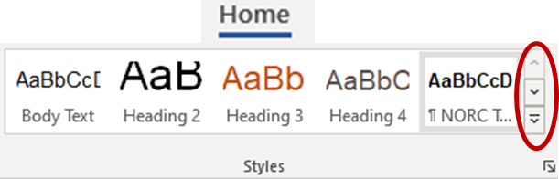
Additional styles in the Styles Task Panel:  - Home tab > Click the dialog box launcher (diagonal arrow) bottom right in the Styles group. The Styles task pane will appear. If the task pane is floating, double-click the title bar. Click “Show Preview” in the bottom. | 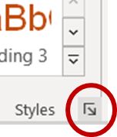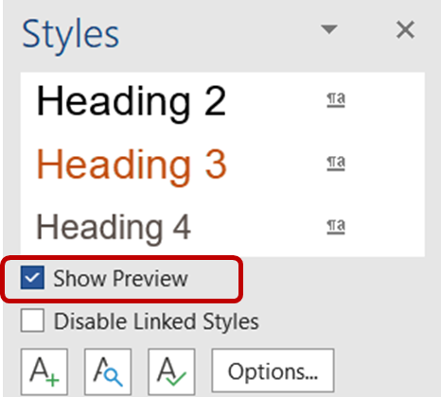

Introduction (Heading 2)

Heading 3

Heading 4

Heading 5
Study Background and Purpose (NORC Inline Heading L1). Body Text. Lorem ipsum ulpa laborum.
Study Background and Purpose (NORC Inline Heading L2). Body Text. Lorem ipsum ulpa laborum.
- List Bullet
- List Bullet 2
- List Bullet 3

Apply Color
This template has the NORC color theme. Color codes are for specific shades of colors. Use the range colors that have been assigned a code.
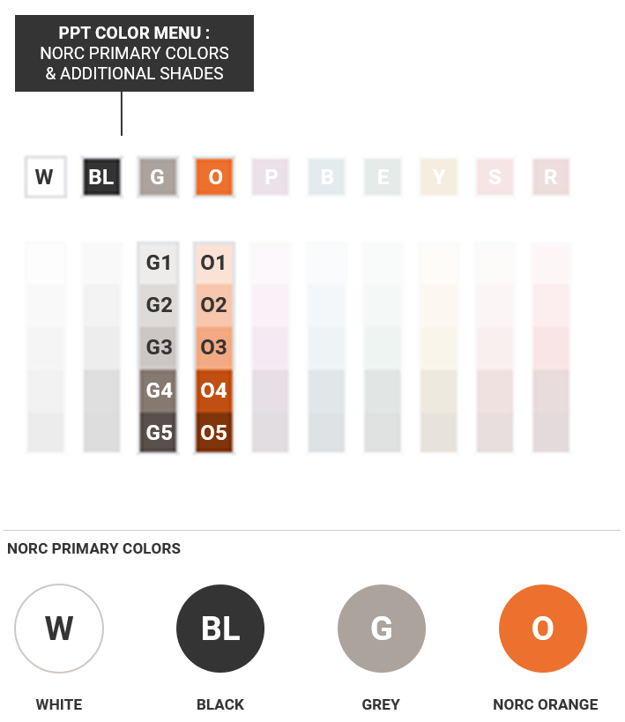
“Quote Block. This quote box is located under the Quick Parts Menu.”
– Name or descriptor

Insert Built-in NOR Experience, Call Out,
and Quote Block
NORC Experience
Example of text Example of text
Example of text Example of text
Example of text Example of text
Example of text Example of text
Call Out Box
This callout box is located under the Quick Parts Menu.

- Place cursor on a blank paragraph space near the area you want the text box to appear > select Insert tab > click Text Box button > select from the gallery of NORC text boxes  Additional Built-in Features:  - Under Insert Tab > Cover Page > NORC’s Report Cover  - Insert Tab > Header, Footer > NORC’s Report styles  - Reference Tab > Table of Contents > NORC’s Report TOC | 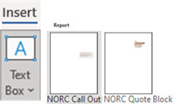

Insert Exhibits
Exhibits Library: Download NORC PPT Template  & PPT Setup File  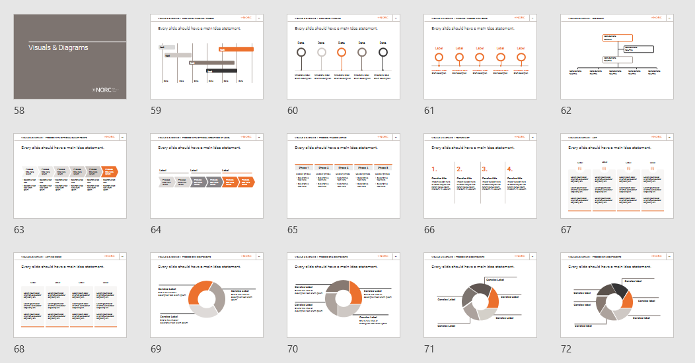 | Icons: Download  NORC Icon Library  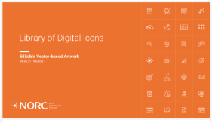

Exhibit 1. NORC Exhibit Caption

Example Exhibit
Source: Xxxxxx xxxxxxx
Insert Tables  - Apply a NORC table style. Select table > under the  Table Design tab > select table design.  - NORC 1 Report Table is the default style for this template. | 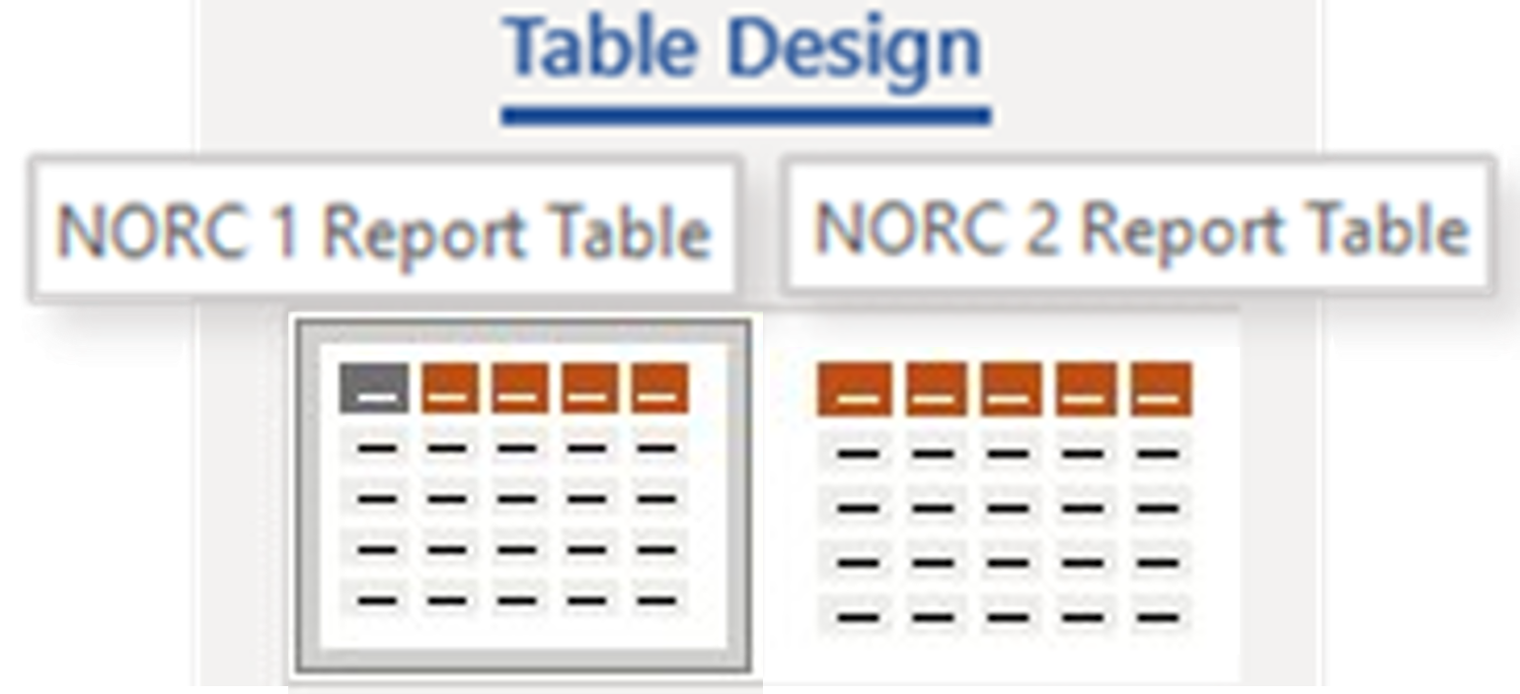
Table 1. NORC Table Caption
NORC Table Header 2 | NORC Table Head 2 | NORC Table Head 2 | NORC Table Head 2
NORC Table Body Left | NORC Table Body L | NORC Table Body L | NORC Table Body L
NORC Table Body Left | NORC Table Body L  - Table Bullet 1  - Table Bullet 2 | NORC Table Body L  - Table Bullet 1  - Table Bullet 2 | NORC Table Body L  - Table Bullet 1  - Table Bullet 2
Table 2. NORC Table Caption
NORC Table Header 2 | NORC Table Head 2 | NORC Table Head 2 | NORC Table Head 2
NORC Table Body L  - Table Bullet 1 | NORC Table Body L  - Table Bullet 1 | NORC Table Body L  - Table Bullet 1 | NORC Table Body L  - Table Bullet 1
NORC Condensed table option (tables that have heavy text & multiple rows and columns)
Table 3. NORC Table Caption
N Table Head | N Table Head | N Table Head | N Table Head | N Table Head | N Table Head
N Table Body | N Table Body | N Table Body | N Table Body | N Table Body | N Table Body
N Table Body | N Table Body | N Table Body | N Table Body | N Table Body | N Table Body
NORC Alternative table option
Table 4. NORC Table Caption
NORC Table Head | NORC Table Head | NORC Table Head
NORC Table Body | NORC Table Body | NORC Table Body
NORC Table Body | NORC Table Body | NORC Table Body

[ insert footnote about original survey ]
Denominators of descriptive statistics vary by item due to item nonresponse and survey skip logic.
Cite Pew Data
Footnote Text style. Exhibit and Table caption styles can be found in the Styles Task Panel.

